**Measure Energy Consumption**

**Introduction:**

The problem at hand is to create an automated system that

measures energy consumption , analysis the data ,and provides

visualizations for informed decision making .This solution aims

to enhance efficiency , accuracy ,and ease of understanding in

managing energy consumption across various sectors.

**Problem Statement:**

Explore Innovative techniques such as time series analysis and machine learning models to predict future energy consumption pattern .

**To Measure of future energy consumption Various Techniques and Technologies are employed , including:**

1. **Time Series analysis:**

A time series analysis encompasses statistical methods for analyzing time series data . These methods enable us to extract meaningful statistics , patterns and other characteristics of the data . Time series are visualized with the help of line charts.

Here are some examples for time series data.

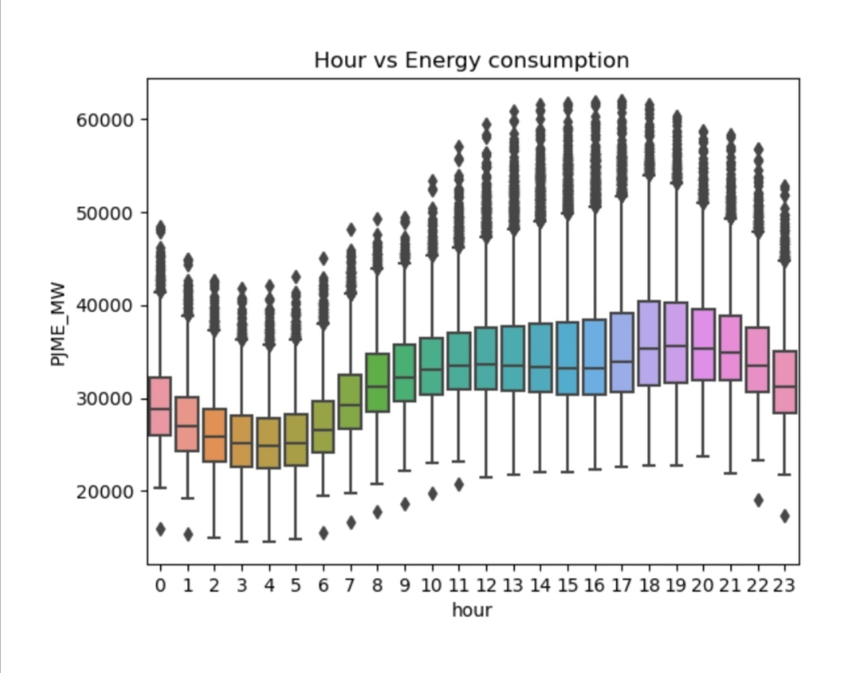

* It is an hour based dataset lineplot model.

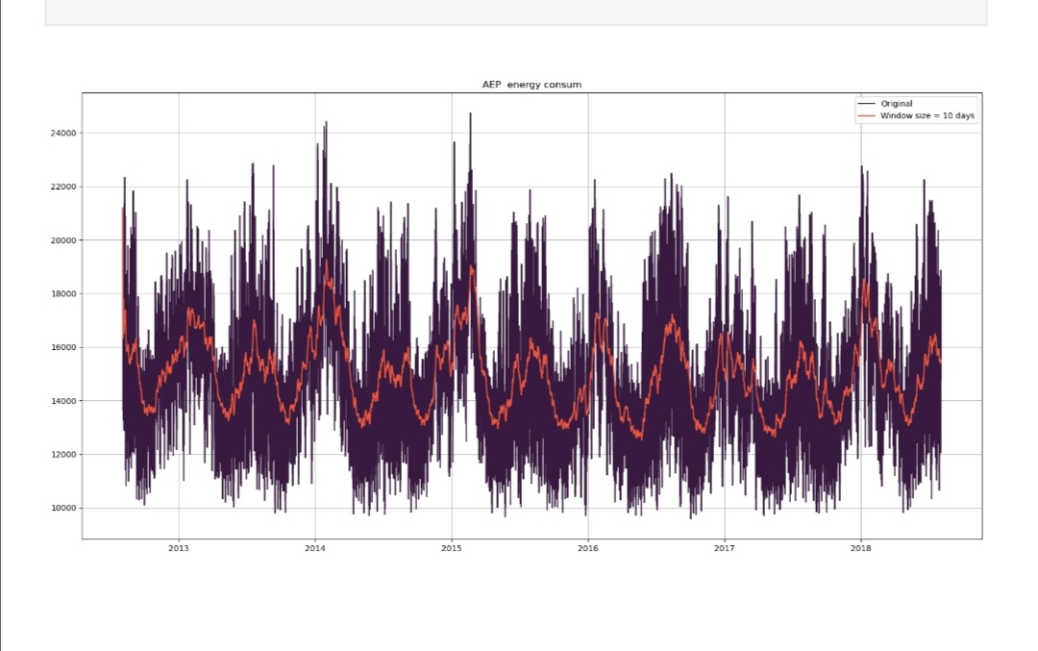

* It is a yearly based dataset.

Here we can see the variance of energy Consumption according to time like(hourly,monthly,yearly) Like this we can predict from past dataset.

 Time series data are collected based on certain periods which have constants value (hourly, daily, weekly or monthly), it can be used to forecast or predict future circumstance.

Like this the time series analysis method shows some variation among duration of time from this variation we are easy to predict future energy consumption by using machine learning models.

Various Common Methods for are,

* **Descriptive Statistics:** Start by examining basic statistics like mean, median, variance, and standard deviation to understand the central tendency and variability in the time series data.
* **Time Plot:** Create a simple line chart to visualize the time series data over time. This helps in identifying trends and seasonality.
* **Autocorrelation and Partial Autocorrelation**: These functions help in identifying the correlation between a time series and its lagged values. Autocorrelation plots can help determine the order of autoregressive (AR) and moving average (MA) terms in ARIMA modeling.
* **ARIMA (AutoRegressive Integrated Moving Average):** ARIMA models are a popular choice for time series forecasting. They involve differencing the time series data to make it stationary and then modeling it using autoregressive (AR) and moving average (MA) terms.
* **Seasonal Decomposition:** Decompose a time series into its seasonal, trend, and residual components to better understand its underlying patterns.
* **SARIMA (Seasonal ARIMA**): SARIMA extends ARIMA models to incorporate seasonality. It includes seasonal differencing, seasonal autoregressive, and seasonal moving average terms.
* **Neural Networks:** Deep learning techniques, including recurrent neural networks (RNNs) and convolutional neural networks (CNNs), can be used for time series analysis and forecasting.
* **Cluster Analysis:** Cluster similar time series together to identify patterns or anomalies within groups of time series.
* **Bayesian Structural Time Series (BSTS):** Bayesian methods can be used to estimate and forecast time series data while incorporating uncertainty.
* **Anomaly Detection:** Use techniques like statistical process control charts or machine learning models to identify unusual patterns or outliers in time series data.

**2 ) Machine Learning Models:**

A machine learning model is a program that can find patterns or make decisions from a previously unseen dataset. For example, in natural language processing, machine learning models can parse and correctly recognize the intent behind previously unheard sentences or combinations of words.

For Example:

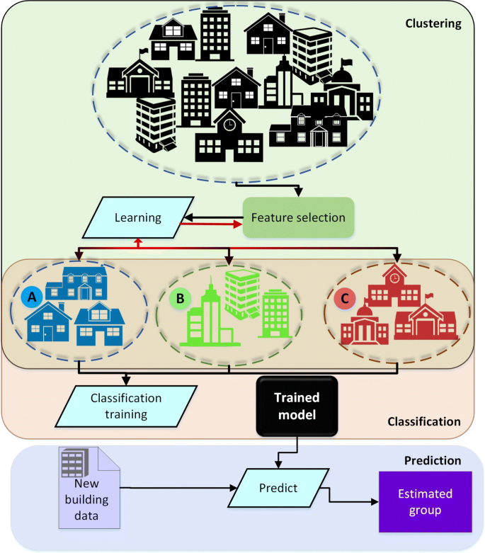

The above picture conveys how the machine learning models gets worked ,here the datasets are feeded into some machine learning models like decisiontree ,random forest etc..

Here are the some common machine learning model methods,

Certainly! There are various methods and techniques for building machine learning models, depending on the problem you're trying to solve and the type of data you have. Here are some common methods and approaches for machine learning:

* **Supervised Learning:**

- Linear Regression: Used for predicting a continuous target variable.

- Logistic Regression: Used for binary classification problems.

- Decision Trees: Tree-based models used for both classification and regression.

- Random Forest: An ensemble method that combines multiple decision trees for improved performance.

- Support Vector Machines (SVM): Used for classification and regression tasks by finding a hyperplane that best separates data.

- K-Nearest Neighbors (K-NN): A simple and versatile algorithm for classification and regression based on proximity to neighbors.

- Naive Bayes: Probabilistic classifiers based on Bayes' theorem, often used for text classification and spam detection.

- Neural Networks: Deep learning models, including feedforward neural networks, convolutional neural networks (CNNs), and recurrent neural networks (RNNs), for various tasks like image recognition, natural language processing, and time series prediction.

* **Unsupervised Learning:**

- K-Means Clustering: Used to group similar data points into clusters.

- Hierarchical Clustering: Builds a hierarchy of clusters, which can be visualized as a dendrogram.

* **Semi-Supervised Learning**: Utilizes a combination of labeled and unlabeled data for training.
* **Ensemble Learning:**

- Bagging: Combines multiple models (e.g., Random Forest) for improved robustness.

- Boosting: Builds a strong model by sequentially training weak models (e.g., AdaBoost, Gradient Boosting).

**3) Regression Analysis:**

Regression analysis is a statistical technique used to model the relationship between a dependent variable (also known as the response or outcome variable) and one or more independent variables (also known as predictors or explanatory variables). There are various methods and techniques for regression analysis, depending on the nature of the data and the goals of the analysis. Here are some common methods for regression analysis:

* **Linear Regression**: Linear regression is the most basic and widely used form of regression analysis. It models the relationship between the dependent variable and one or more independent variables by fitting a linear equation to the data. There are two main types: simple linear regression (one independent variable) and multiple linear regression (multiple independent variables).
* **Logistic Regression:** Logistic regression is used when the dependent variable is binary (e.g., 0 or 1). It models the probability of the binary outcome as a function of independent variables.
* **Bayesian Regression:** Bayesian regression incorporates Bayesian principles to estimate model parameters. It provides uncertainty estimates for regression coefficients.
* **Support Vector Regression (SVR):** SVR is a regression technique based on Support Vector Machines. It's particularly useful when dealing with high-dimensional data or when the relationship between variables is complex.
* **K-Nearest Neighbors (KNN) Regression:** KNN regression estimates the dependent variable by averaging the values of its k-nearest neighbors in the training dataset.
* **Random Forest Regression:**Random Forest is an ensemble learning method that can be used for regression tasks by averaging the predictions of multiple decision trees.
* **Gradient Boosting Regression:** Gradient boosting algorithms, like XGBoost, LightGBM, and CatBoost, are powerful ensemble methods for regression that build multiple decision trees sequentially.

**These are Some Various Techniques used for predicting future energy consumption.**